AAW

AWS ADVANCED ASSIGNMENT-7

DAY 15-16

ARAVIND G KUMAR

**Project 1: WORKING WITH LAMBDA.**

Task 1: Creating S3 buckets.

* Go to S3 from service tab.
* Select create buckets.
* Create two buckets.
* S0urcebucket and Destinati0nbucket.

Source bucket:

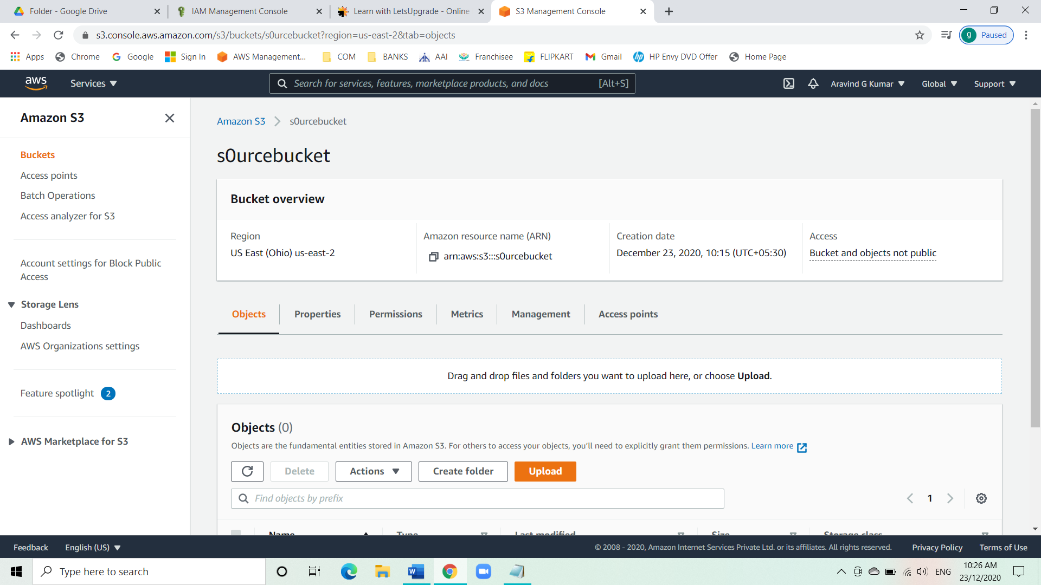

Destination bucket:

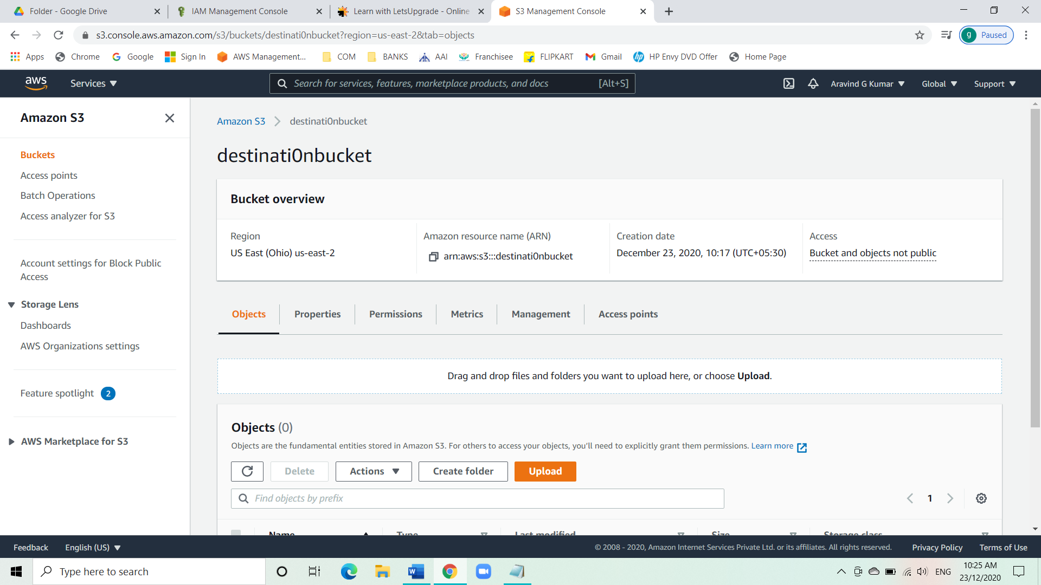

Task 2: Create an IAM policy.

* Go to IAM from service tab.
* Select the policy option.
* Click on create policy.
* Click on JSON.
* Edit the JSON policy with the script.

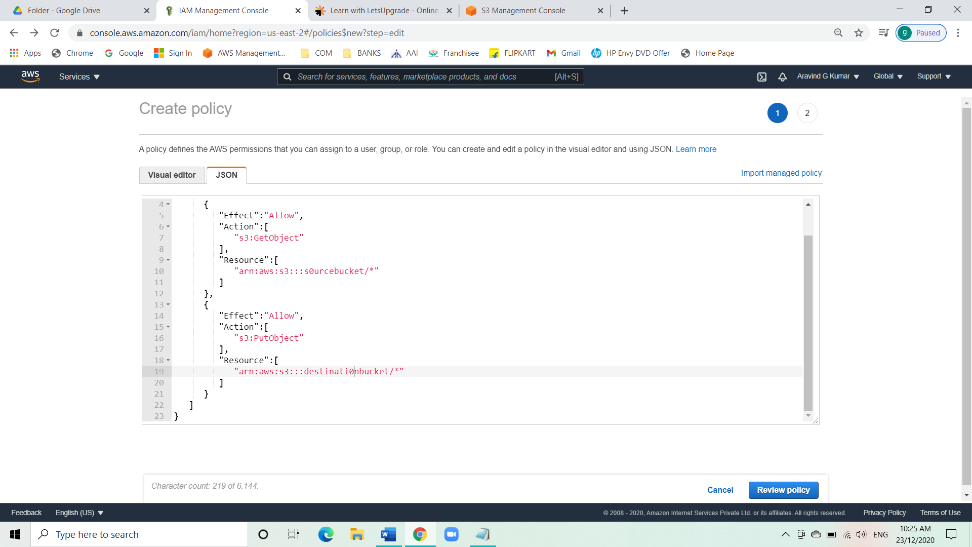

* Then review the policy.

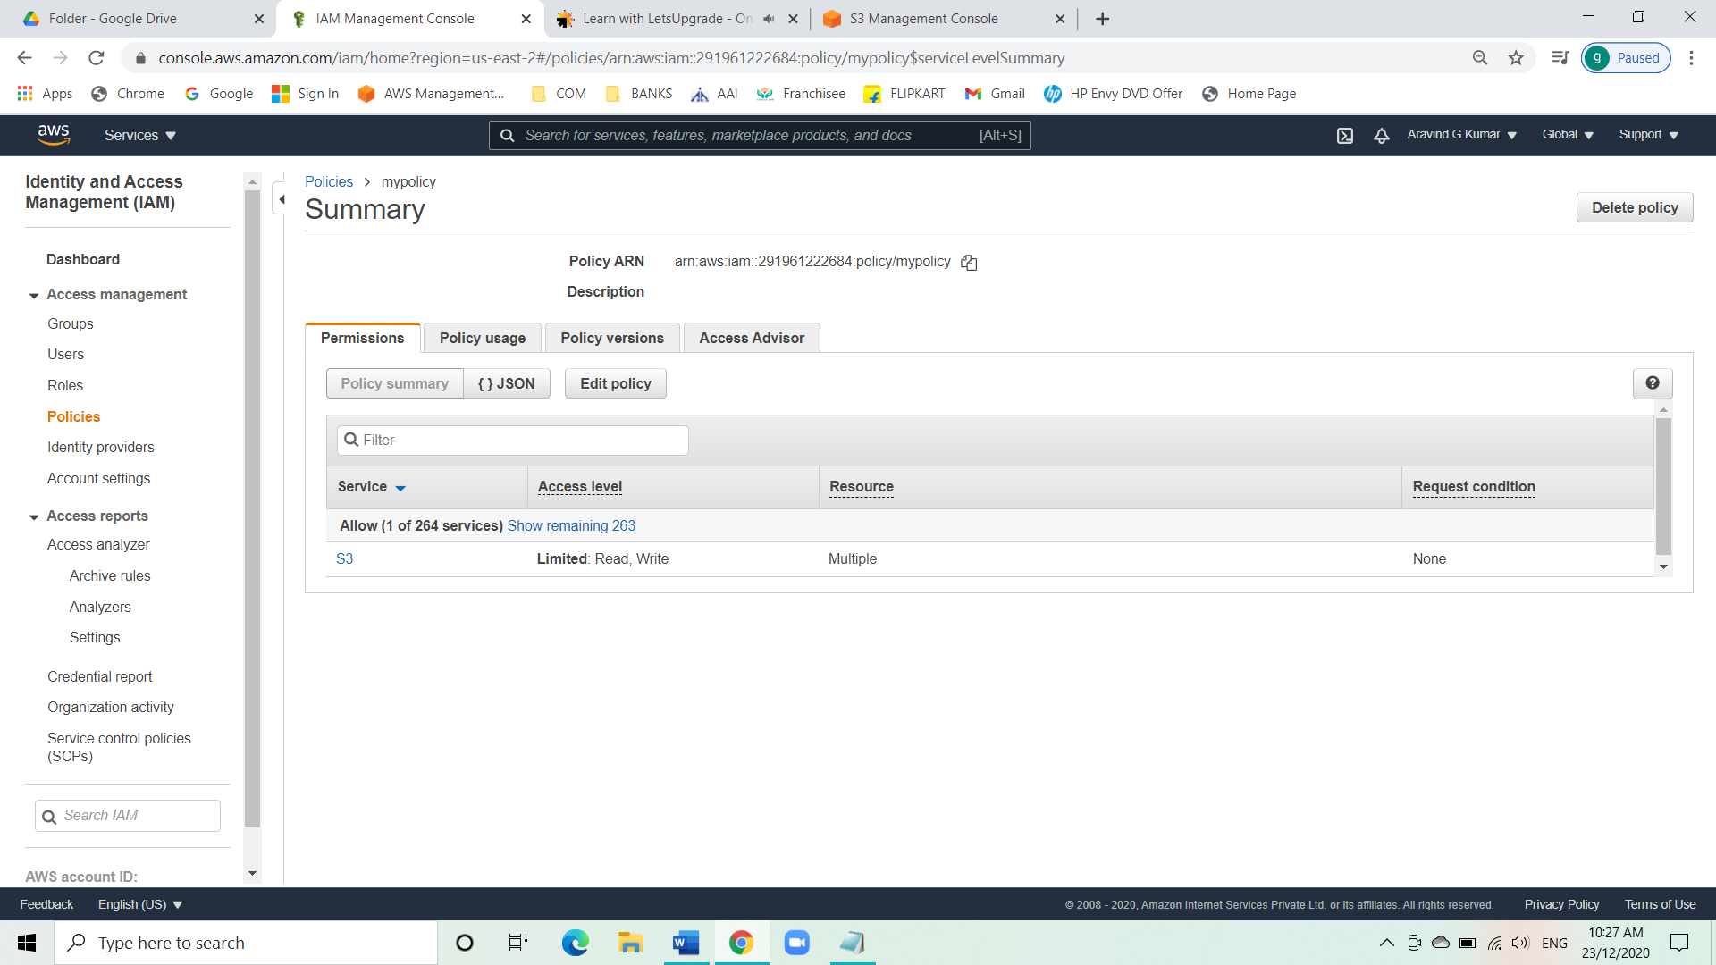

Task 3: Create an IAM role.

* Go to IAM from service tab.
* Select the role option.
* Click on create role.
* Select Lambda.
* Click on permission and select the policy we created.
* Give a role name and create the role.

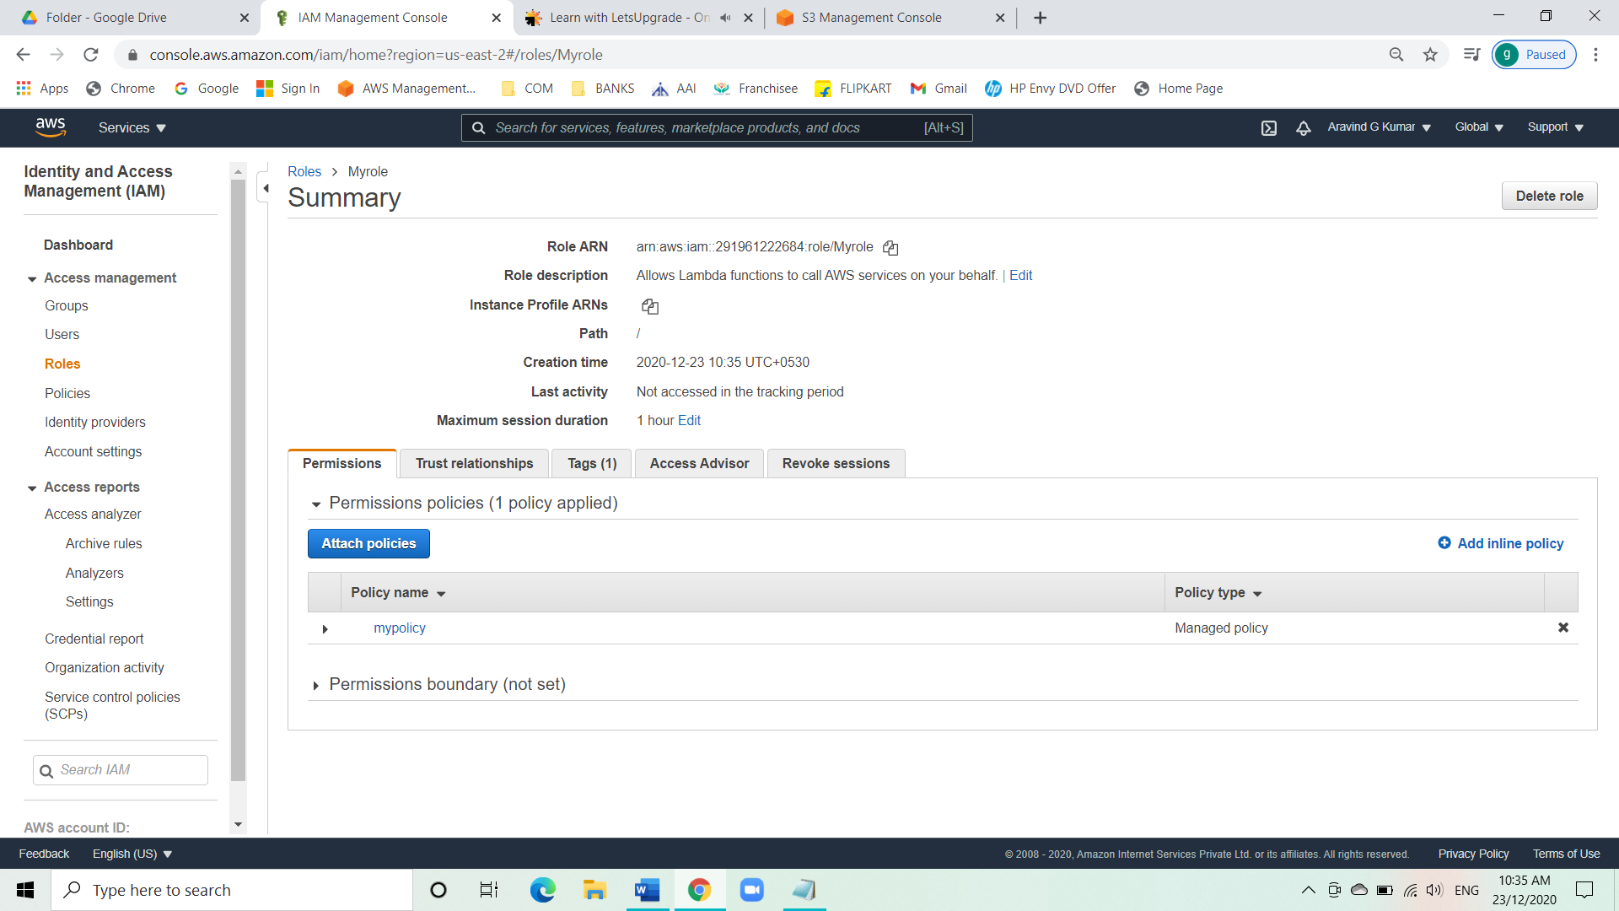

Task 4: Create a Lambda function.

* Go to Lambda from service tab.
* Under functions click on create functions.
* Give the function a name as s0urcebucket.
* Under change default execution role, select use an existing role and select the IAM role we created.
* Click on create function.

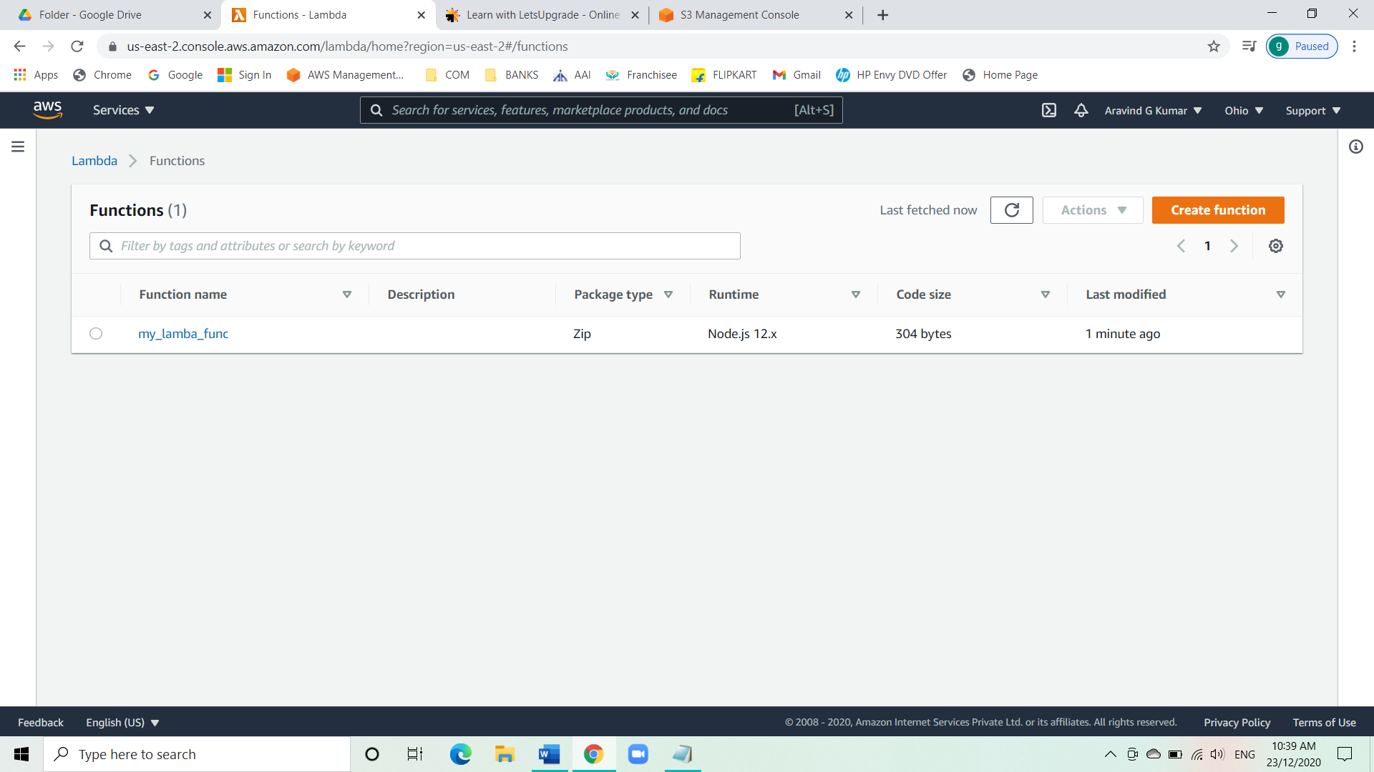

* Click on the created lambda function and scroll down.
* Edit the Nodejs script.

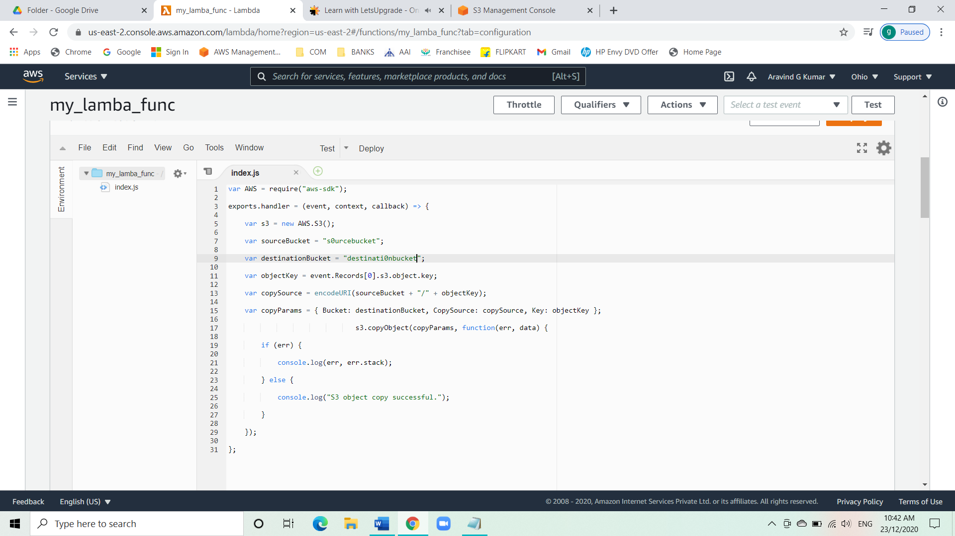

* Now add triggers.
* Under the trigger configuration select the type as S3.
* Give the bucket name as s0urcebucket and add the trigger.

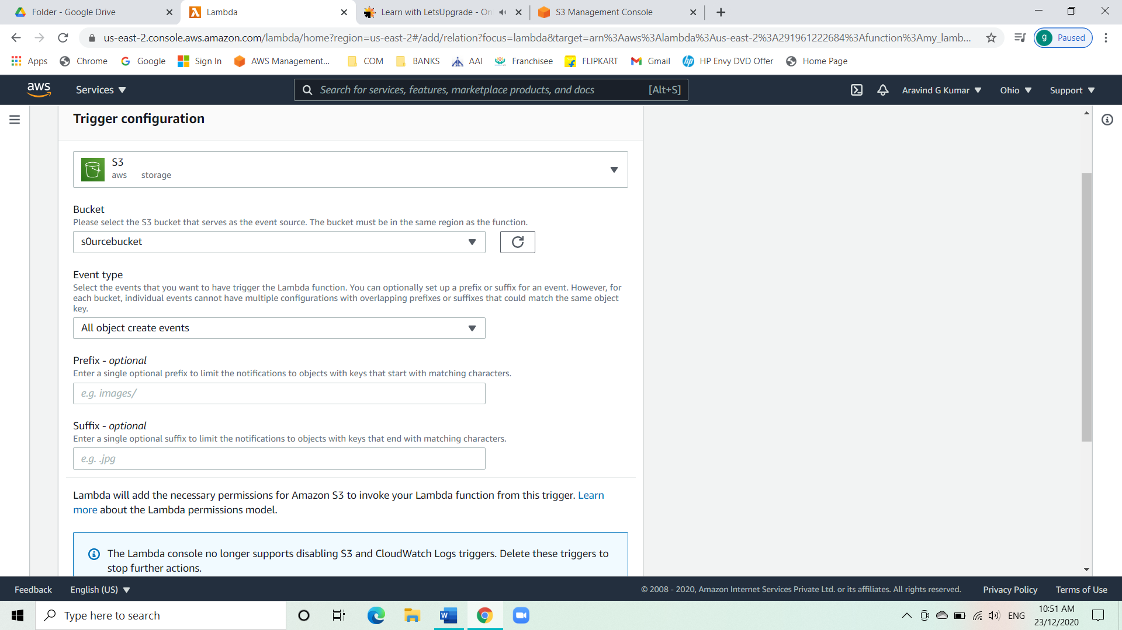

Task 5: Test by uploading objects into the source bucket.

* Go to S3 from the service tab.
* Select the source bucket and add a file.

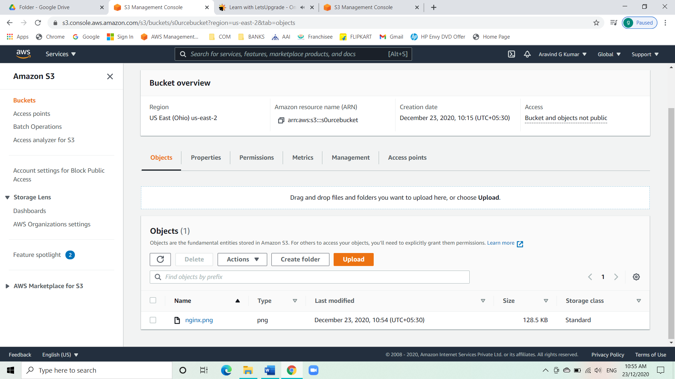

* Check the same file is added to the destination file.

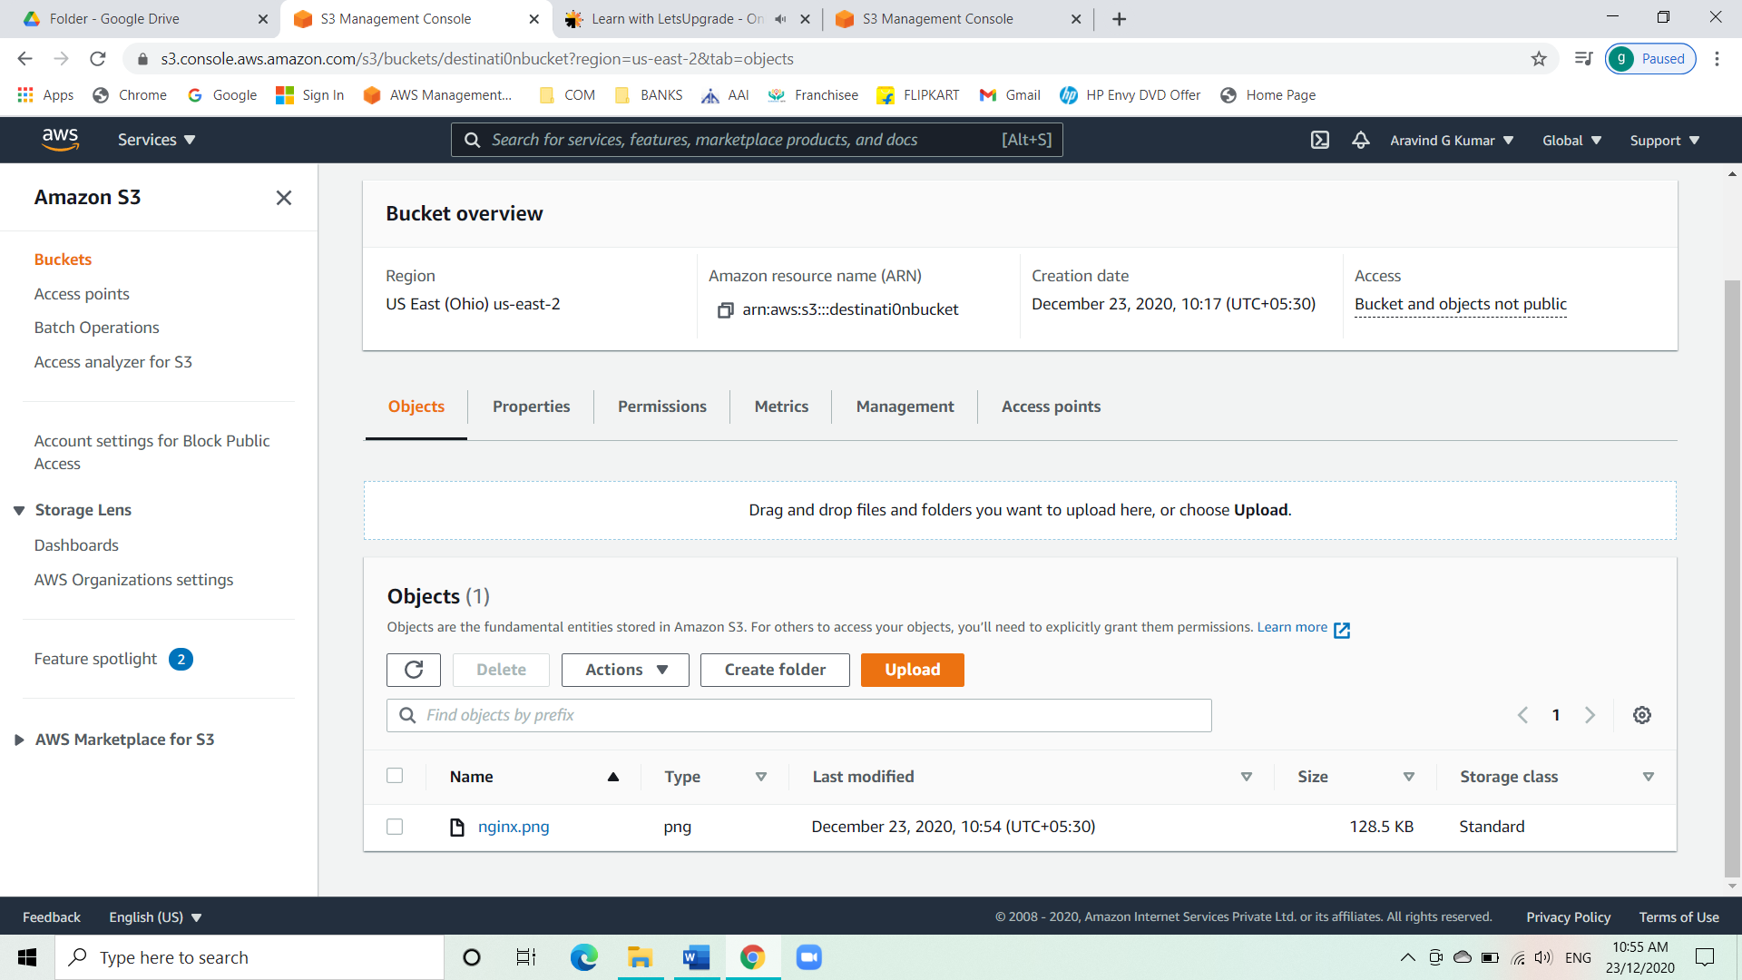

**Project 2: WORKING WITH ECS USING FARGATE.**

Task 1: Getting started with ECS.

* Go to ECS from service tab.
* Under ECS clusters click on get started.

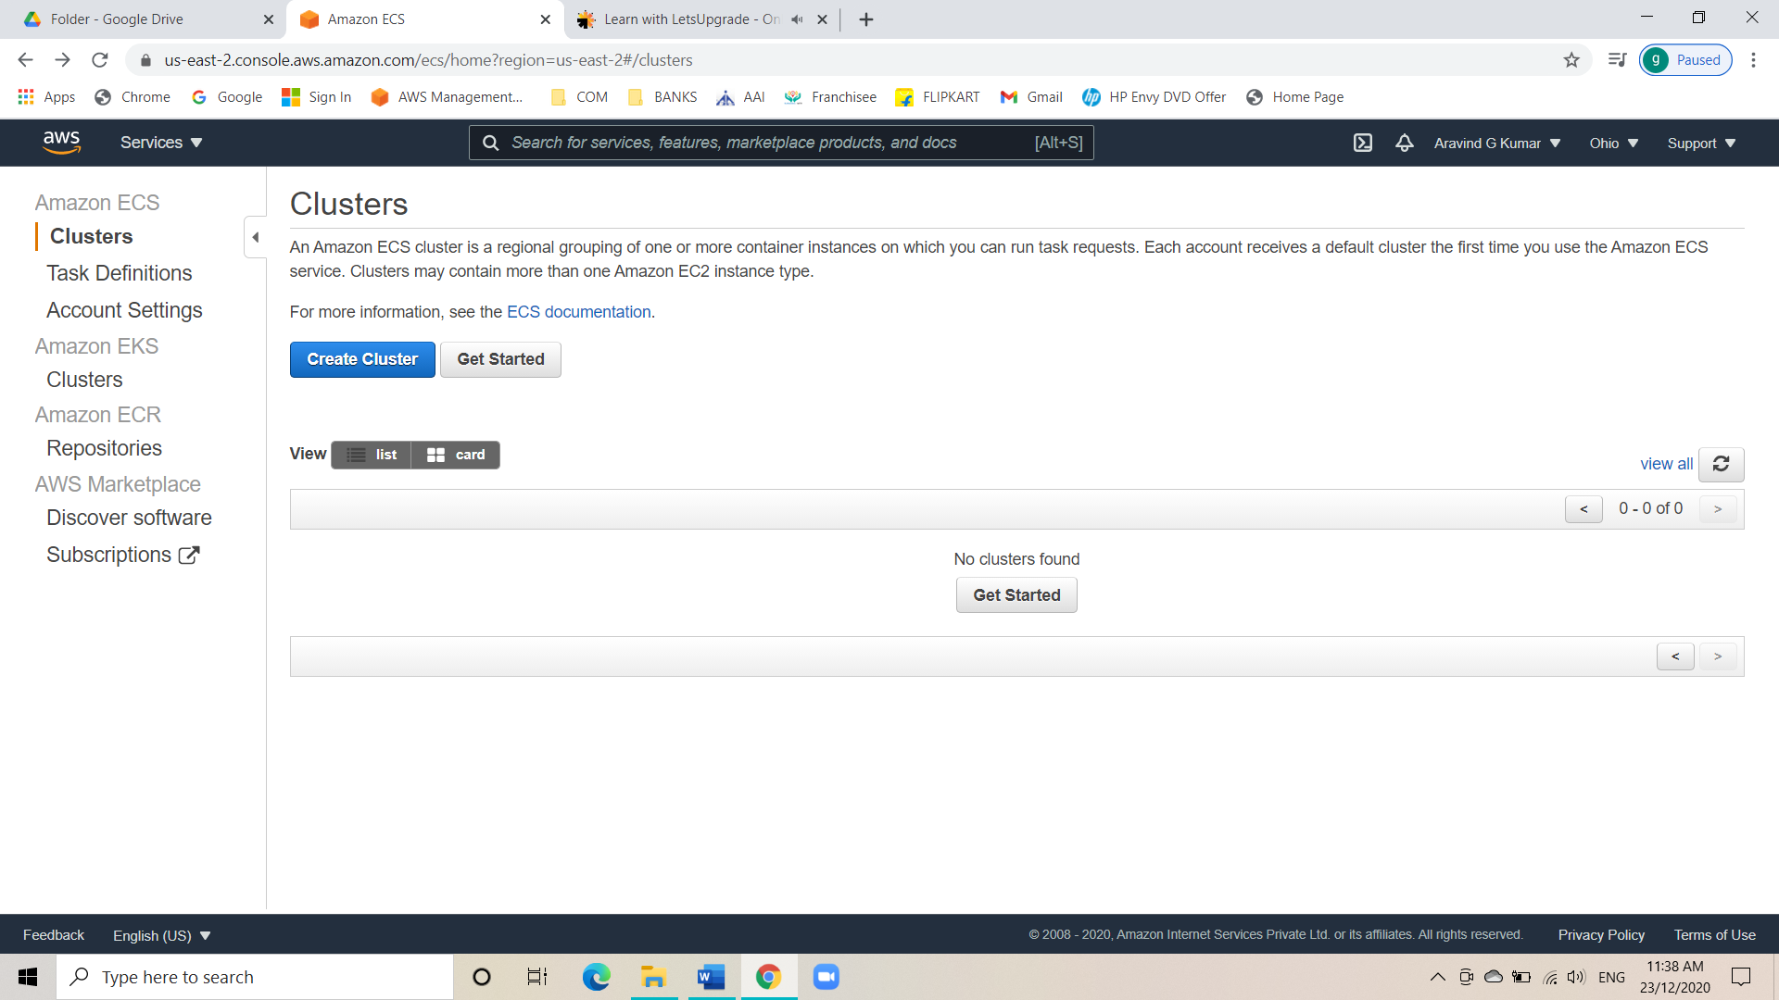

* Under container and task section leave everything as default.

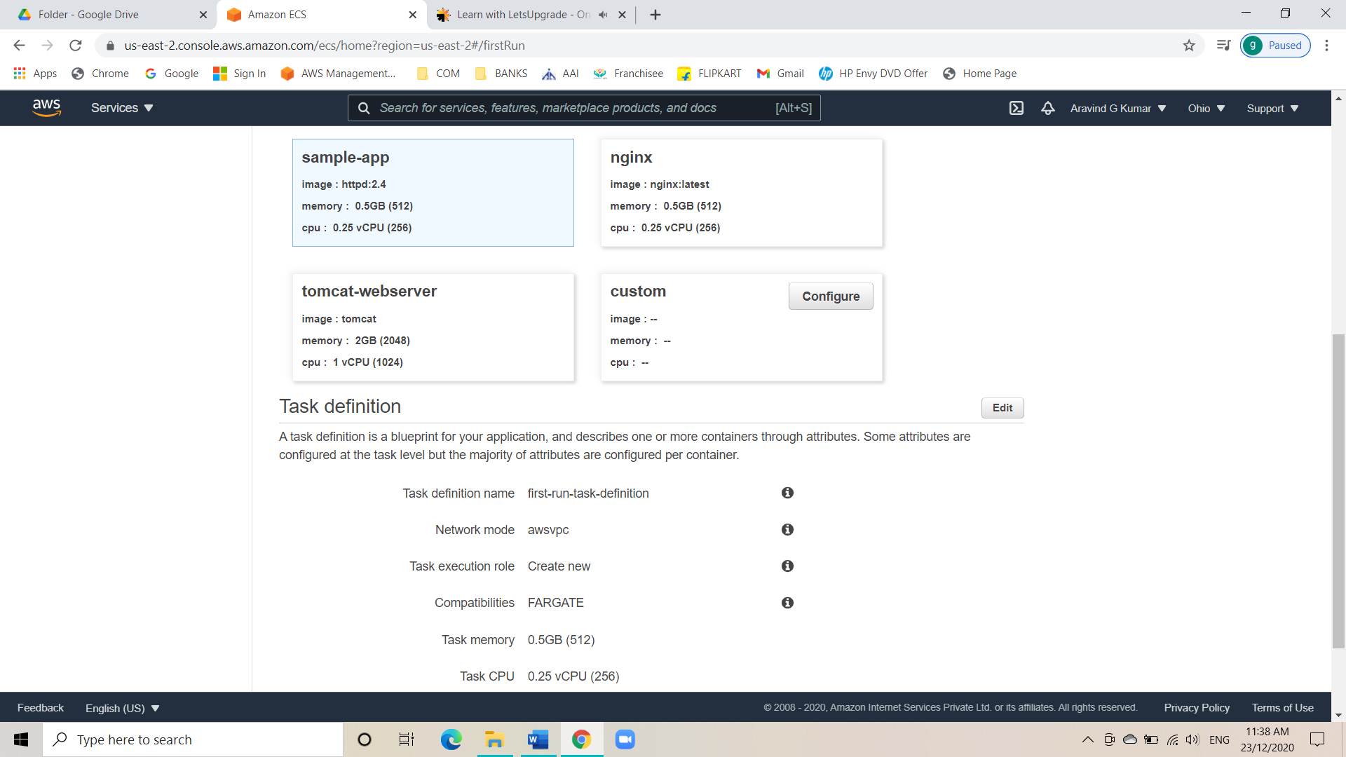

* Go to the next page i.e., services, and leave everything as default there.

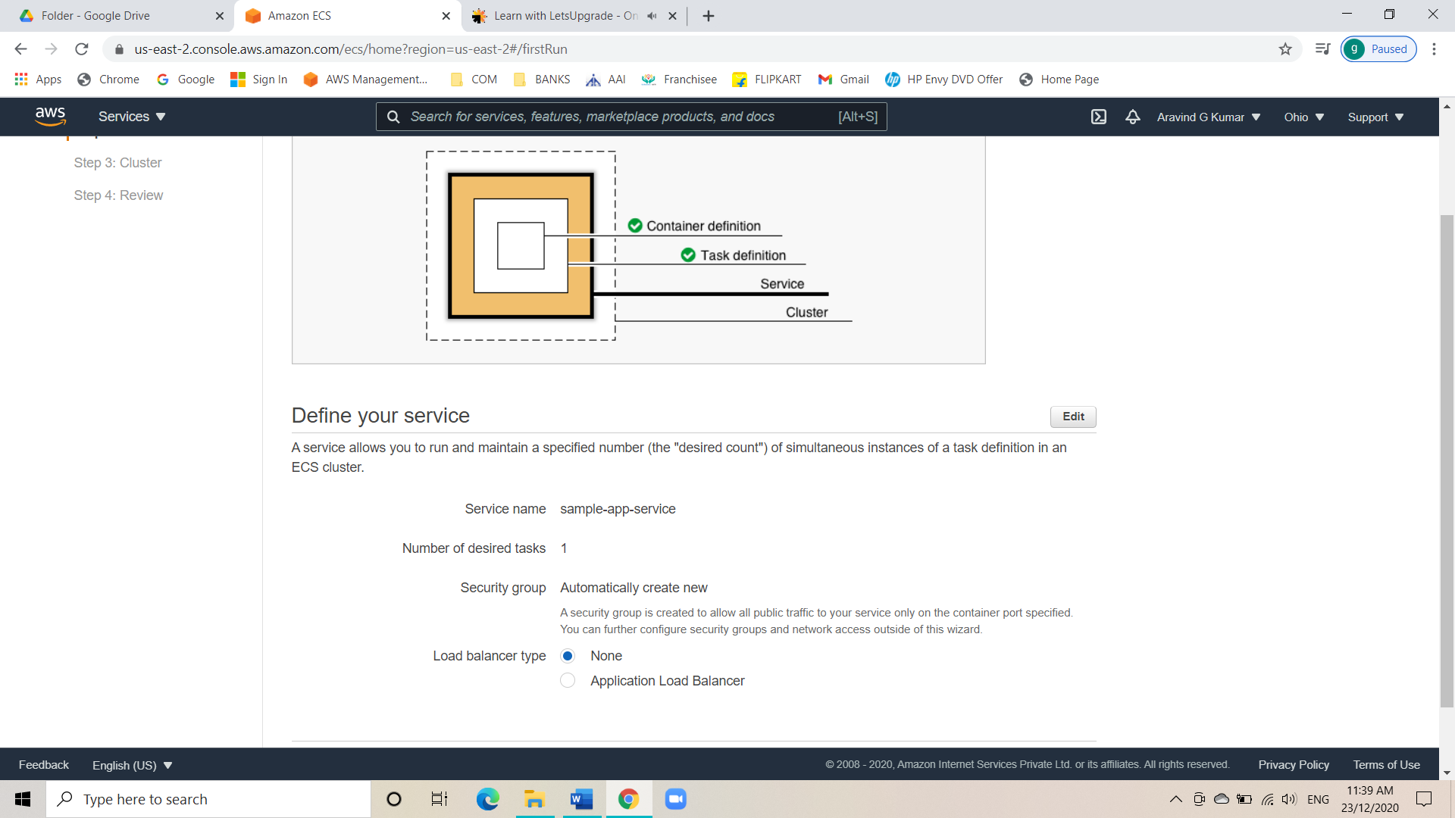

* Now under cluster configure section give the cluster a name and proceed ahead.

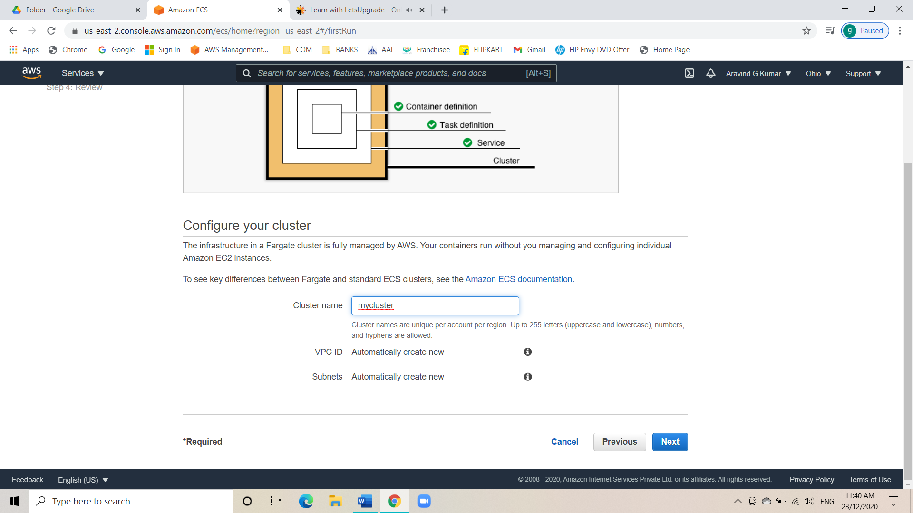

* Now create the cluster.
* Click on the created cluster.

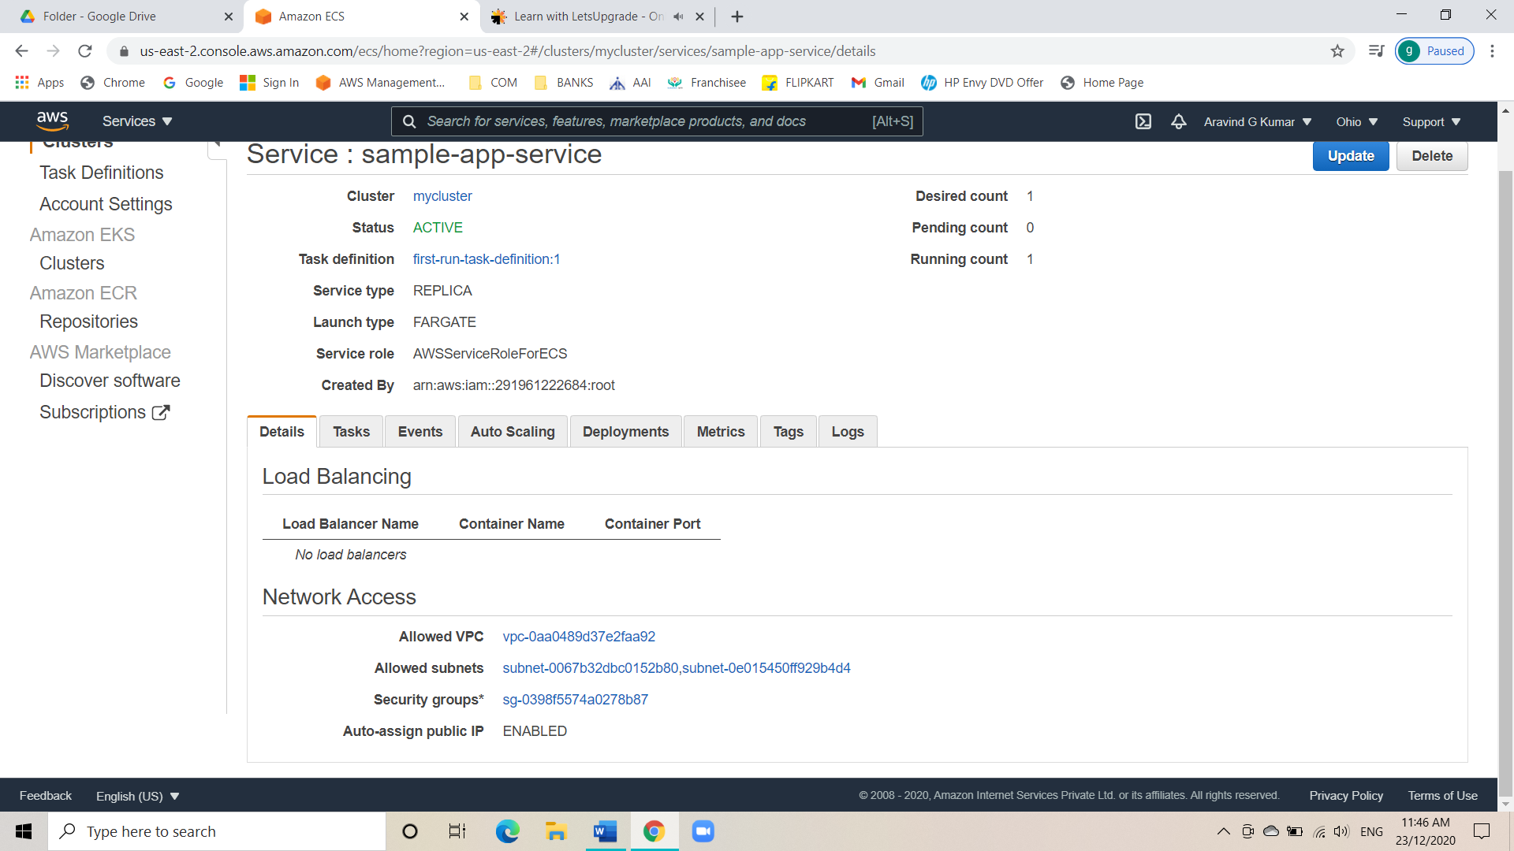

* Move into the tasks option and select the task.

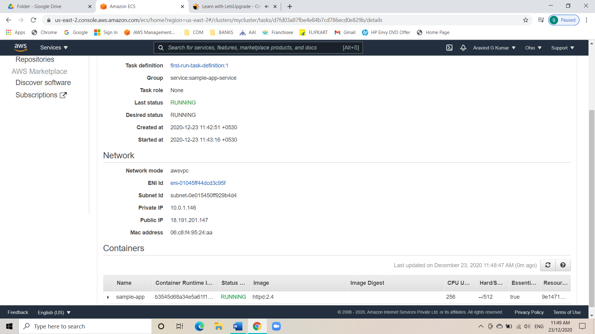

* Click on the ENI id.

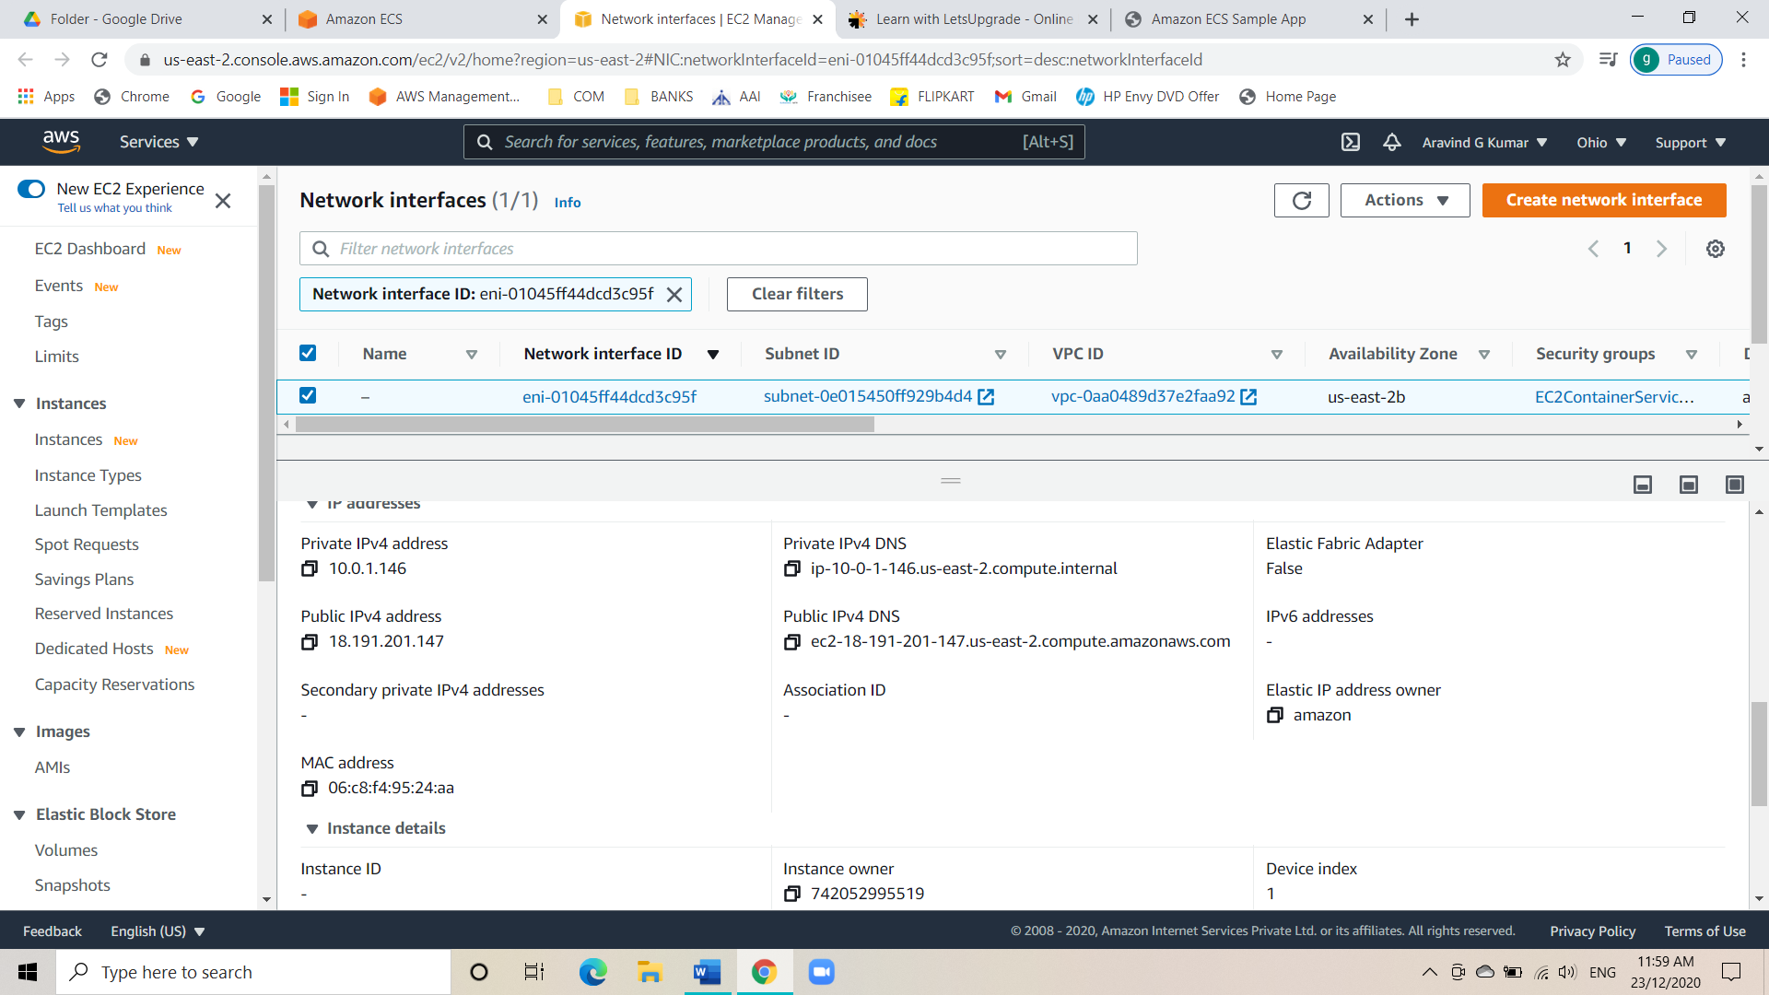

* Copy the Public IPV4 and paste it on another tab to see the launched application.

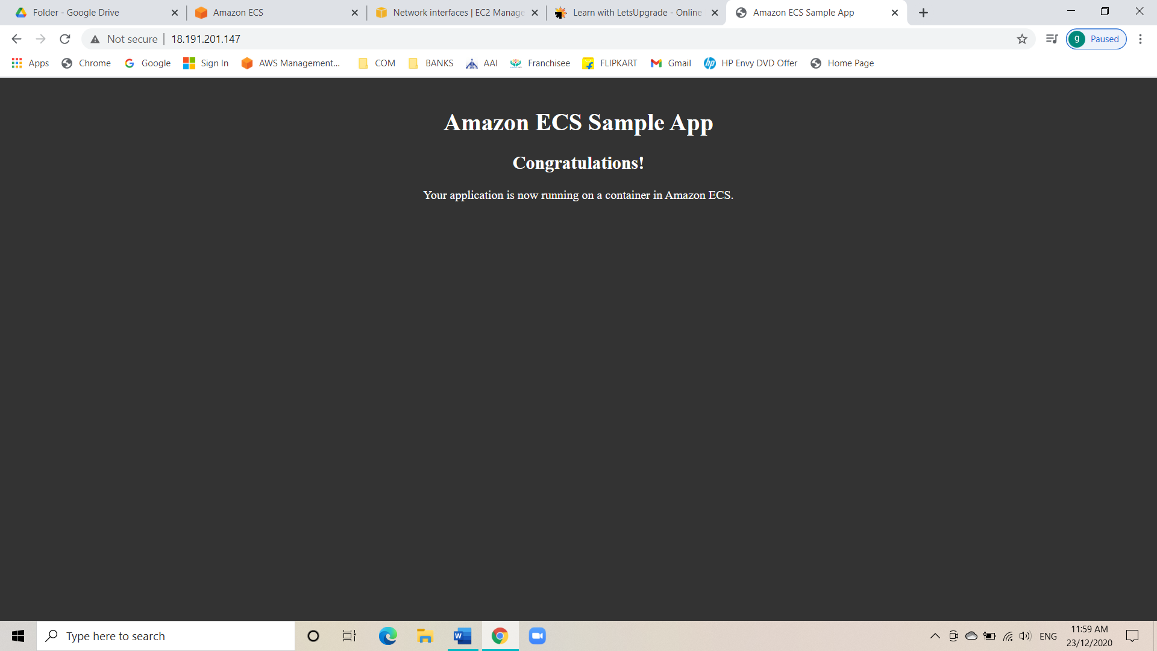

* Application is deployed.